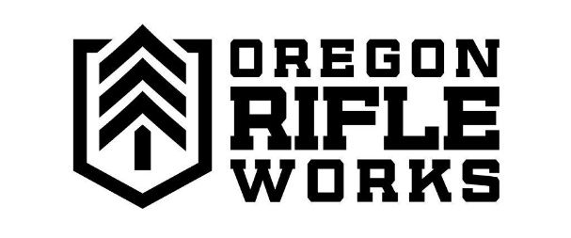
NFA Services

Form 4
Here at Oregon Rifleworks, we provide Form 4 services for NFA items purchased from us or transferred through the store. Though we don’t have a SilencerShop kiosk, we have knowledgeable and NFA-experienced staff who will guide you through the entire process. Utilizing the ATF Eforms system, we will have your form submitted in under an hour, and can do your fingerprints and photos here at the shop as well. Call the store with any questions or to make an appointment.
Fingerprints and Photos
Feel comfortable completing the form on your own but just need prints and photos done? We can help! We offer fingerprinting and photo services here and can often do them same day. Just be sure to call the store ahead of time to make sure we’re ready for you.

FEES
We charge a $100 processing fee for any Form service or NFA transfer.
We charge $25 to complete fingerprints and photos.

