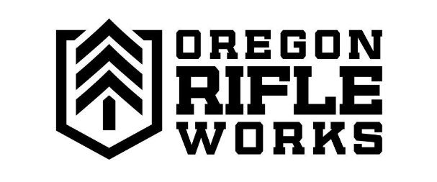
NFA Services

ATF Form 4
Here at Oregon Rifleworks, we provide Form 4 services for NFA items purchased from us or transferred through the store. We have a SilencerShop kiosk, as well as knowledgeable and NFA-experienced staff who will guide you through the entire process. To make a purchase through SilencerShop, go to:
silencershop.com/oregonrifleworks
and complete the checkout process. To make a purchase directly through our shop, give us a call or swing on by the store. Once your item has arrived at the shop, an employee will be in contact to inform you of the next steps.
Fingerprints and Photos
Feel comfortable completing the form on your own but just need prints and photos done? We can help! We offer fingerprinting and photo services here and can often do them same day. Just be sure to call the store ahead of time to make sure we’re ready for you.

FEES
We charge a $100 processing fee for any NFA transfer that is not purchased in our store or though SilencerShop.
We charge $25 to complete fingerprints and photos.

